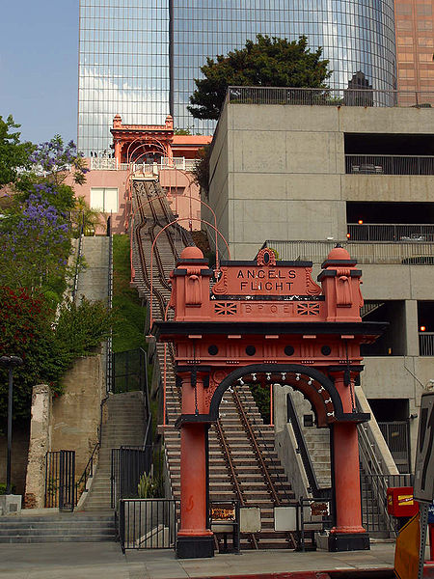



The Fallen Angel

A mystery story for the Asylum® RPG, by Jon Lemich

# How to Run this Story

## Not Your Daddy’s Gaming Module

A traditional gaming module is a series of interconnected events that the players’ characters (PCs) experience in either a linear order, or some variable order depending on their decisions. A mystery story differs from the traditional module format. In a mystery story, the GM presents the situation that the PCs discover and hooks them into the mystery. The GM presents clues and threats, then the players take it from there. They assemble the clues into timelines and invent theories to explain them. Then they go and investigate their theories, rather than follow a string of clues from scene to scene.

Your challenges as the GM are different as well. Instead of preparing for specific scenes designed for you, learning every aspect of them, and implementing them as the fine-tuned mini-games they are, you’re more of a coach. Your goal is to help the players through the process of examining the clues, devising theories, evaluating their theories, then inducing ways to test their theories. Then they test their theories, discover more clues, and refine them. Eventually their theories lead them to a suspect and inform their new objective: Capturing the suspect.

## Summary

Though there aren’t many specific scenes in *The Fallen Angel*, this story begins with a scene where the players arrive at the lower station for Angel’s Flight and attempt to deal with the LAPD IAG detectives. They meet their “opponent” – Cpt. Ian Petri – and McBride and Hill, their rival detectives. What should be obvious to the PCs, but not necessarily the detectives, is that the motive of the attack was not robbery. However, the dead contractor doesn’t have a purse or wallet; and the dead lawyer doesn’t have his watch or wallet, either. Because the police assume that a stick-up gone bad is a likely motive, they’re not searching the wider area for the stolen items – just the street and stairs near the crime scene. The players won’t be familiar with police procedure, but their characters are. They should become aware that the police aren’t searching the Bunker Hill area because they think it’s a botched stickup.

This is a freebie for the characters with the Academics or Empathy skill. If they search further out, mark off a half hour. They will find *Maia’s Laptop Bag and Phone (see handout).*

After that, we have another scene – once the players are done collecting evidence and talking to the IAG detectives, they need to stop pushing forward relentlessly and think. This is the critical scene that separates this mystery from typical RPG mysteries. The PCs go to the Pantry Café on Figueroa in the middle of the night for coffee, grab a booth, assemble the information they have and shoot theories back and forth.

As the GM, it’s very important that the players *stop investigating in order to discuss theories*. It sets the tone that this is a game about solving a mystery by figuring it out, not by following a chain of clues that eventually leads to the solution. This will probably take a little OOC talk from you. If they don’t like you jumping them to the diner scene, explain that their characters should stop and toss some theories around. It’s up to them – they can sit in a parked car near the crime scene, go back to one of their apartments to talk, or stop at a McDonalds if they want.

If one of your players has a rare facilitator-type personality, she’ll probably start guiding the discussion productively. Also, if one of your players is a mystery buff, she’ll probably start talking in terms of means/motive/opportunity, or the 5 W’s, etc. If not, you can prompt them to ask general questions and see if they can answer them. There are a few ways to hack at a mystery:

* One way is to build a timeline given the facts you know, then start proposing theories inside the timeline, filling in the blanks
* Another way is to list all the potential suspects, and evaluate their means, motive and opportunity – this would include hypothetical suspects (“maybe the lawyer had a love affair”)
* The classic “5 W’s” approach – build theories by filling in each of Who, What, When, Where, and Why?
* Love and Money: The two most common motives for murder. Who stands to benefit or reap revenge from the deaths of one or both of these victims?

After the diner scene, the game becomes almost entirely freeform, with the exception of the events that occur at specific times in the future. Even those are plastic – for instance, if the PCs persuade the detectives to focus on Fletcher early (either to divert them and waste their time or because they believe he really is the killer), it’s possible that part of the timeline will be accelerated.

The actual killer was the 19yo son of the lawyer, angry at his wealthy, famous, estranged father for seeing another woman, for refusing to pay for his college, for cutting off alimony to his mother, and for leaving him and his mother and hardly ever seeing them. He stalked his father after seeing him at dinner with Maia, and when he confronted his father, filled with adolescent rage and armed with an illegal gun, Maia accidentally made things turn violent by turning invisible. It wasn’t enough to save her, and it panicked Warren, Jr. into shooting them both.

The PCs need to eliminate several suspects to get to this conclusion. The obvious suspects seem to be:

* The local host agent
* The goblin who contracted with Maia
* A crooked cop who stole the gun from the crime scene
* The Angel’s Flight operator with a violent history
* The lawyer’s client, who he had a quarrel with that day

The LAPD will eliminate the first two mortal suspects for the PCs, if they focus on supernatural suspects.

On day 1, the slain contractor’s landlady will call the police to identify her as her tenant at her apartment at 739 Garland in Westlake, apartment 3C.

The apartment has the following additional clues:

* Maia has a lot of high tech stuff. A fancy digital camera, night vision goggles,
* Maia kept a lot of cash in a strongbox; as if she was paid cash for whatever job she did.
* She does not have a computer or phone here. (The PCs may have already found these).
* Maia’s contract with a goblin name d Wick, and his address: 420 Magnolia, Compton and phone number 310-555-1231.

## Hook

The players play an Asylum cell in downtown Los Angeles. They’re not sure, but they think there are other cells in Hollywood, the valley, and Santa Monica. But of course, the nature of the Asylum is that they just can’t be sure. Still, they have met a few local contractors, and they keep tabs on them. They are an established cell, and they have contacts in the mortal world to feed them information so they can respond to threats.

Tonight, one of their contacts tips them off that a known contractor who they suspected of being an Asylum agent was murdered. Their handler confirms that she is a rare duck: An asylum member on inactive status. That, naturally, implies that she’s ex-asylum – which is something they thought was impossible until tonight. Their handler informs them that it’s their job to figure out who killed her, why, and take care of any messes.

## Phases

Detectives go through fairly discrete phases when solving a crime. These phases are based on the behavior and goal of the detective at each point in the process. The phases are distinct from one another, but sometimes the detective has to backtrack to an earlier phase or repeat one. This is natural progression. Feel free to explain the phases to the players at the start of the game, in your own words, careful not to give away any spoilers.

1. First, the detectives collect the clues that are available.

In a *traditional* RPG module, these would then lead to a suspect or location where a prepared encounter would take place, after which a new clue would be available, which would lead to the next scene. In a genuine mystery story, though, this is not the case. The clues are open ended and *mysterious.* That is, it’s unclear where they *should* lead to because of all the different places they *could* lead to*.*

1. Second, the detectives assemble the clues into narrative theories that explain them.

Because the LAPD is going to be investigating this crime while the PCs do, they can’t afford the luxury of tracking down every unknown. It’s much faster to assemble the clues into theories, and then test them. This process can luck them into the right suspect quickly; and if they’re wrong, it will eliminate a suspect just as fast. Meanwhile, the LAPD is going to be hunting down all the details for them, and their contacts there will pass them along as the boys in blue find stuff. The PCs’ goal is to get out *ahead* of the investigation.

As the GM, once they have all the initial clues, you will need to ask the players to have a scene with just their own characters, discussing their theories about the crime. Say something like this:

*“Now we advance time slightly. You’ve brought your clues and notes together at the Pantry Café on Figueroa, about ten blocks away from the crime scene. It was the only place open you could get to quickly, where you could snag a quiet booth to go over the evidence. Traditionally, here’s where your team eats pie and sips coffee and shoots theories back and forth until you have a couple good ones to go on.”*

1. Third, the detectives go test and refine their theories.

There should be a few theories floating around, but nothing certain. A lot more information is needed. But there’s no time to go systematically collect it all. Instead, they can rely on their LAPD contacts to tell them if something is discovered, and instead focus on their most likely theories, looking for specific clues that would confirm or disprove their most likely hypotheses.

As they investigate, they will find clues and hear from witnesses and suspects. Some of this information may disprove their theories, or force them to modify them. An alibi here, physical evidence failing to match up there… Given how ambiguous the initial situation is, they will almost definitely have to abandon theories as they go.

1. Fourth, the detectives will decide they have solved the crime.

Eventually they’ll find a theory that fits all the clues and which has no glaring holes or contrary evidence without a solid explanation. See the timeline below for what actually happened. They should be able to come close to a perfect re-creation of those events.

1. Last, they have to catch the criminal.

Actually, in this story, they can decide not to catch the criminal themselves. The criminal is a mortal, and while he saw some minor magic happen, briefly, most mortal authorities would dismiss him as having a hallucination or stress reaction. In the end, if they solve the case correctly, they can pass their information on to the LAPD and let them hunt down and arrest the killer.

Or… They could choose to do it themselves. That’s up to your players.

## Time

Part of the plot is a race against time. In order for an RPG mystery to work, the PCs have to get all the clues. Therefore, when they go off in search of information, they will usually find it easily. NPCs may try to lie or avoid giving away information, but the PCs should be able to use their skills and powers to cut through the lies and bluster. Clues may be hidden, but if a contractor knows what he’s looking for, nothing can stay hidden for long. If the players look for a clue and fail to find it when in fact, it really exists, they will be confused indefinitely and fail to solve the crime. We don’t want that to happen. So the challenge of the story is not finding clues that the PCs look for… it’s finding them before the LAPD does.

Below is a time tracker. As the story advances, tell the players how much time passes as they maneuver around Los Angeles

# Timeline of Events

Below is a timeline of events leading up to the murder of the two victims at the base of Angel’s Flight. Your players should piece together their own timeline during play.

### Prior to the day of the murder…

1993: Warren Latimer and Dorothy Franks get married

1994: Warren Jr. is born

1999: Harry Liu arrested for assault and battery and drunk and disorderly after a bar fight. Assault charges dropped. He gets time served for the drunk and disorderly.

2001: Harry Liu gets a DUI.

2003: Warren Latimer and Dorothy Franks get divorced

2003: Harry Liu arrested for assault and battery against his boss at a Ford dealership (he was a service salesman). He put his boss in the hospital with broken ribs, nose, concussion, and ruptured spleen from the severity of the beating.

2004: Harry Liu convicted and sentenced to 8 years.

2005: Antonius Fletcher arrested for possession of 8oz marijuana, gets time served

2006: Antonius Fletcher arrested for possession of 2oz of marijuana, gets 12 months plus 12 months parole

2007: Antonius Fletcher released 4 months early for good behavior, gets 16 months parole

2008: Harry Liu released from prison early, but with 12 years parole.

2009: Warren Latimer attempts to dissolve alimony payments and fails

2009: Antonius Fletcher arrested, tried and imprisoned for possession of illegal firearm. The gun was planted by a crooked cop during a traffic stop. The cop, Lt. Will Sherman, saw Fletcher’s drug bust history and wanted to get a conviction as part of his reputation for getting illegal guns off the street. He used a drug sniffing dog and cued the animal illegally. The arrest was recorded on video, but the dog cue is not clearly visible, and the gun plant can’t be seen by the camera at all. As this is his 3rd strike, Fletcher is automatically sentenced to life in prison under the three strikes law.

2009: Salvador attempts to manipulate the election of the city manager of Santa Monica, in a power grab. His candidate is a cruel conservative masquerading as a Latino democrat. A good deal of money is at stake for a lot of powerful people.

2010: The Santa Monica Asylum Cell dissects Salvador’s conspiracy and releases several people from blackmail and mind control magic. However, in a final confrontation with an angel, the Santa Monica cell is nearly wiped out. Maia, a human contractor with the cell, is the only survivor. She fled at the end.

2011: Maia begins rebuilding her life. All of her contracts expire, and she reverts to being “merely human.” She remains off the grid, though, acting as an unlicensed private investigator. By the end of the year she has contracted with Wick, the goblin, for invisibility magic. Maia trades him her memories of the events that led to her cell’s destruction. Wick values the information about corruption and violence, since he’s styled himself as the leader of a street gang.

2012 Warren Jr. graduates high school, turns 18; child support stops; Warren Sr. doesn’t pay anything for college. He gets into USC on a half-ride scholarship anyway. In the summer he moves into a group house with some other students and former students near campus, in South Central, LA. After a few months there, he has purchased a 9mm Glock “used” from a former student who one of his housemates knows, for “self defense.” As the child of a rich family, and being black, young, and prideful, he believes the hype about the neighborhood, taking some pride in living in “the ghetto” and really believes he needs the gun.

2012: Wick and Maia renew their contract amicably. Wick has profited greatly from it, and intends to continue to do so. Maia has also profited, becoming the under-the-table investigator for Warren Latimer, for when he needs to get information without any traceable connection to the source. Maia and Warren start a romantic entanglement.

2012: Antonius Fletcher released on parole under state mandate to clear beds, despite his life sentence. He contacts Warren Latimer.

### 2013, the year of the murder

January: Warren Latimer attempts to dissolve alimony payments to Dorothy Franks. As she is now receiving income from a trust fund, and earning money as a concert cellist, he argues that she is able to support herself at her current lifestyle without his aid.

February: Latimer files a lawsuit against the LAPD on behalf of Antonius Fletcher for $10 million for wrongful arrest and imprisonment, police misconduct, and abuse of power.

March: Cpl. Ian Petri, LAPD IAD opens an investigation as a result of the suit. He finds a history of dismissed complaints against the ambitious Lt. Sherman. He decides to make Sherman his crony and offers to bury the case by presenting an unequivocal report with no findings of inappropriate behavior to the jury, despite the complaint history.

April: A judge hears the request from Warren. Warren Latimer’s alimony payments are approved to stop in April 2014. Dorothy is furious, but keeps her feelings to herself.

May 17: Media hears about the pre-trial hearings in the *Fletcher vs. LAPD* case.

June 5: Petri traces the gun from the Fletcher conviction to Miles Smith, the deceased father man named Dwayne Smith, who was arrested by Sherman in 2008. The gun was not listed on confiscated items or evidence.

### Day 0 (day of the murder), Friday, June 7, 2013

7:30am: Petri and Sherman meet in a discrete public location, fishing on Santa Monica pier in the morning (Santa Monica is outside LAPD jurisdiction), while most of the pier is closed except for fishermen. Petri confronts Sherman about the gun. Maia, tailing Sherman, records the conversation. She recorded this dialog:

“If the jury learns that the gun disappeared after an arrest you made just 9 months before it was found on Fletcher, it’ll torpedo the our defense, Will.”

“Ian, I don’t know what to say. I never saw the gun before I found it in Fletcher’s bag.”

“Don’t bullshit me Will. I deserve better after all I’ve done for you. We’re on the same team. We both want to get scum like Fletcher off the streets. You did what you had to do. I’m not here to ass fuck you for it. I’m going to bury this. I’m going to sit on this and push for a settlement.”

“Thanks, Ian.”

“Do you know why I’m going to do that?”

“No, but I have a suspicion you’re about to tell me.”

“I want you to take my job when I’m gone. And you can’t do that if you get busted down for planting a gun.”

“When you’re gone?”

“I’m going to be promoted to the Chief of PSB. And I want a loyal IAG captain.” *[Professional Standards Bureau – the job is a stepping stone to Chief of Police]*

“Well, OK. I can assure you that I’m the man for the job.”

“Great. Where can I get more guys like you, Will?” [They laugh, say goodbye, and depart]

8:00am: Petri begins pulling strings to push a settlement offer.

12:00pm: Maia brings the evidence to Latimer. She shows him the recording, but keeps it on her laptop.

1:00pm: LAPD’s lawyer, Craig Barrett, calls Warren and offers a settlement deal of $500,000.

2:00pm: Warren Latimer calls Antonius Fletcher and leaves this voice mail:

“Mr. Fletcher, the LAPD has offered a settlement in your case. However, I believe we should decline and proceed with the suit. I have information that will likely win our case and prove you were set up. Call or stop by. I’ll be here until 4 today.”

3:30pm: Warren Jr. and his mother Dorothy Franks meet up in Santa Monica. She’s buying him things at the mall before she and WJ head over to her timeshare in Avalon for the weekend. The semester is over, and she’s disappointed that he is in danger of losing his scholarship for bad grades. They argue about him partying too much. She demands he move into the dorms, and he refuses. They fight about that, too.

4:00pm: Fletcher stops by Latimer’s office just before close. Maia has gone home for the day, but the secretary Jennifer Chang, sticks around. Fletcher wants to accept the settlement. He’s thrilled that he can get $500,000 without spending any more time, and it’s a sure thing. Warren tells him about the new evidence, and it stuns Fletcher, but he would still rather have the sure thing. Warren reminds him it’s only $350K after the legal fees he will be charging. Fletcher has been poor his whole life, and a half million dollars – even after his legal fees cut it down to $350K – is still a lot of money to him. He gets mad and calls Warren a money grubbing parasite and accuses him of wanting to continue because he wants to rack up more fees, but damned if he’s going to let some lawyer gamble with his life. He storms out, opening the door, and the secretary (who heard raised voices before but not exactly what was said) hears:

“We’ll talk about it again when you’ve had some time to think about it.”

“Fuck you, man. You work for me. Do what I say or I will terminate your ass.”

“Don’t tell me you’re willing to let them get away with it.”

“*You* don’t tell *me* what to do, asshole.” [Antonius slams the door as he leaves. The safety glass in the door cracks.]

4:30pm: Warren sends his secretary home.

5:00pm: Warren finally leaves the office. He goes to meet up with Maia and discuss how to persuade Fletcher to reject the settlement.

6:00pm: Dorothy and WJ go to a seafood restaurant near Marina Del Rey. Maia and Warren Sr. go to dinner at a sushi restaurant near Marina Del Rey. It’s not a big coincidence: There’s a food festival this weekend in the area, and the restaurants are all offering well-publicized specials.

7:30pm: Dorothy and WJ notice Warren Sr. and Maia canoodling at the Cold Stone Creamery. WJ is mad at his estranged father about the cut-off alimony, and he’s angry to see him with a strange [white] woman. Against his mother’s protests, he leaves her to follow them.

8:00pm: Maia and Warren Sr. go to a bar for coctails. WJ follows and waits outside.

8:30pm: Dorothy takes the ferry to Avalon alone.

10:00pm: Maia and Warren Sr. leave the bar. They take a cab back to Bunker Hill. WJ gets a cab and follows them.

10:45pm: Maia and Warren Sr. go for a walk around Bunker Hill as the restaurants serving the city center there close down and people head to trendier areas for the night. They catch the last ride on Angel’s Flight, prolonging their date.

### The murder…

**11:00pm: WJ confronts Maia and Warren Sr. The argument becomes heated quickly as WJ lists all of his father’s faults to Maia: His coldhearted refusal to pay for his college. His coldhearted treatment of his mother Dorothy. He works himself up, and when Warren Sr. tries to end the confrontation (“That’s enough. We’re leaving.”) WJ takes out his 9mm Glock. Maia (who is still a little intoxicated) panics and uses invisibility magic to disappear, hoping to catch WJ off guard and disarm him. WJ fires and hits her. He then fires and kills his father as well.**

**He panics. To make it look like a robbery, he takes Warren and Maia’s things –stuffing his wallet and watch in her laptop bag – and runs. He wipes the gun and drops it in a trash can nearby. He drops the laptop bag in a dumpster behind a CVS several blocks farther on.**

**The operator of the car, Harry Liu, heard the gunshots. He’s on parole, and a coward. He runs. He calls 911 fifteen minutes later, from his beat up 1997 Camry, at 11:14pm.**

### After the murder…

10:18pm: A squad car arrives on the scene. The responding officers are Central Division officers Cpl. John Parks and PFC. Steve Woiczeski. They split up and secure the scene, looking for any sign of the killer. Parks is the more experienced cop. He recognizes Warren Latimer as the victim. He also finds the gun in the trash can. Since this is so close to a lot of police buildings, etc., he assumes this is a cop’s work. It’s a Glock, a weapon favored by police, and he can tell it’s been wiped down. He’s also aware that Latimer – who has a history of suing the LAPD – is involved in a ten million dollar case. So he steals the gun from the scene out of hate.

10:18pm-midnight: Police and EMTs arrive on scene. Parks and Woiczeski get off duty.

### Day 1 (day the game starts), Saturday, June 8, 2013

12:30am: Cpl. Parks takes his personal car, but doesn’t go home. He drops the gun in the estuary off the Florence Ave. bridge near the 710, Long Beach Parkway. It’s a residential area, and someone sees him do it.

1:00am: Central Division Detectives arrive on the scene. The detective Lt. is Will Sherman. He is forced to recuse himself, and it becomes Chief Petri’s case, as Internal Affairs is called in by the captain when it’s clear who the victim is. Also, while Maia is off the grid for regular folks, she’s on the list of known local contractors, and Makayla Johnson, a night dispatcher, hears the description of Maia:

Caucasian female, 5’5”, approximately 30 years old with brown eyes, braided brown hair and a tattoo of a pair of crossed keys on her left wrist. Several old scars on her left hand and arm.

*Since the keys symbol is the symbol of the Asylum, Makayla calls the PCs when she can get a break.*

1:30am: Makayla Johnson calls the PCs.

2:00am: The PCs arrive at the scene.

# Time Tracker

Use the form on the next page to track time spent in 30 minute chunks. As time passes, certain events will take place. The LAPD investigation will advance, an IAD investigation will start and then advance. The killer and other NPCs will be doing things. The trash man will come… and so on.

Travel time is the critical factor in the traffic capital of the West: Any trip in Bunker Hill will take 30 minutes (15 minutes each way). Any trip in greater Downtown LA will take 60 minutes (30 minutes each way). Any trip in greater Los Angeles will take 90 minutes (45 minutes each way).

If the PCs go to Catalina Island, they have to go to the marina at Long Beach or Marina Del Rey (greater Los Angeles) and then take a ferry (1 hour each way, with departures every 2 hours 6am until 9pm).

Don’t track how long scenes take with a stopwatch. In addition to the travel for a scene, each scene will take 30 minutes. If they try things like shadowing an NPC or staking out an area, ask them how long they’re planning to do it for. If they flippantly answer “until something happens,” start advancing time on them in 2 hour chunks, asking them if they want to continue every time, until either something happens, or they give up.

These times assume the PCs doing normal human stuff, in addition to the story (eating, taking naps, getting coffee, using the bathroom) so you only need to track these things if the PCs do something like sleep for 6 hours. And they will need to sleep at some point.

When the PCs reach a time where an event occurs, the box for that time will have a word. Look that word up in the list of events below the grid.

Note: You don’t have to go square by square. You can advance time in larger chunks. If the PCs want to stake some place out for 3 hours, advance 3 hours. If they want to drive home and sleep for 5 hours, advance the time 5 hours plus travel time (90 minutes – 1.5 hours more).

The time tracker covers what the NPCs are doing.

## Salvador and Wick

You’ll notice Salvador, the host agent, and Wick, the goblin, are not involved in the time tracker. They are supernatural dead ends. Both can tell the PCs Maia’s backstory (the blue text in the timeline, above).

Wick was with his gang, drinking at a bar that he controls. So naturally he could have fabricated that alibi, but for someone like him, nearly any *alibi* will be shaky.

Salvador will not give an alibi. He is the PCs’ enemy, and will fight them if they give him any reason to – and that includes demanding an alibi from him.

## The End

When Warren Latimer, Jr. takes off for Mexico City at 7:15 on Wednesday, the story is effectively over. The PCs could still track him down in Mexico, but it’s out of their jurisdiction. He’s eventually going to go live under an assumed name in Cancun, working as a bartender. But tracking down a fugitive that got away is another story, and likely to take a lot of time. It’s also a good stopping point.

## Day 1, Saturday, June 8, 2013

|  |  |  |  |
| --- | --- | --- | --- |
| ~~Midnight~~ | 6:00am | Noon | 6:00pm |
| ~~12:30am~~ | 6:30am: FERRY | 12:30pm | 6:30pm: TIP OFF |
| ~~1:00am~~ | 7:00am: NEWS | 1:00pm | 7:00pm |
| ~~1:30am~~ | 7:30am | 1:30pm | 7:30pm: STAKEOUT |
| 2:00am: ARRIVAL | 8:00am: HARRY | 2:00pm: CORONER | 8:00pm: LANDLADY |
| 2:30am | 8:30am | 2:30pm | 8:30pm |
| 3:00am: MEDIA | 9:00am | 3:00pm | 9:00pm |
| 3:30am | 9:30am | 3:30pm | 9:30pm |
| 4:00am | 10:00am | 4:00pm | 10:00pm |
| 4:30am | 10:30am | 4:30pm | 10:30pm |
| 5:00am: NEWS | 11:00am | 5:00pm | 11:00pm |
| 5:30am | 11:30am: HARRY | 5:30pm | 11:30pm |

ARRIVAL: The PCs arrive on scene at the lower end of Angel’s Flight. See “Introduction for the Players”

MEDIA: The news media arrives at the crime scene.

NEWS: The newspaper runs a cover story of the murder. See “Handout Day 1 News Story.” It gets to the news stands at 5am, but the TV news doesn’t run the story until 7am (no handout for that).

FERRY: Warren Latimer, Jr. takes the ferry to Avalon to visit his mother.

HARRY: The police bring Harry Liu, Angels Flight operator, in for questioning. He is at the station from 8:00am until 11:30am. He takes a cab home and gets back at noon.

CORONER: The coroner’s report on the deaths comes in. The weapon is confirmed to be a 9mm semiautomatic. The woman was shot in the chest at an angle from the side, piercing her esophagus and lung, and drowned in her own blood. Latimer was shot in the forehead, and died instantly. Both showed powder burns, and it is clear the shots were fired point blank into the enclosed car. There is no idncation that they were killed elsewhere.

TIP OFF: An anonymous tip was called into the central desk, and Makayla passes the information on to the PCs. The tipper describes an LAPD officer dropping something in the estuary that looked like a gun. The tipper goes on to give a decent description of the cop and his car. Makayla identifies the man as Cpl. John Parks, who was the ranking responding officer on the scene. But then, it’d be easy for IAG to identify him, too, and they got the tip an hour before, because Makayla didn’t take the call herself. Cpl. Parks has called out sick today. Normally he would be working until midnight.

STAKEOUT: IAG detectives McBride and Hill stake out Parks’ home in South LA from 7:30pm until 7:30am. Parks stays outside and watches the stakeout, waiting for them to leave.

LANDLADY: Maia’s landlady Gilda Fernandez calls the police to report that she recognizes the woman on the TV news. She lived at 739 Garland in Westlake, apartment 3C. She went by Maia (no last name) and paid cash up front. Makayla calls the PCs to tell them.

## Day 2, Sunday, June 9, 2013

|  |  |  |  |
| --- | --- | --- | --- |
| Midnight | 6:00am | Noon | 6:00pm |
| 12:30am | 6:30am | 12:30pm | 6:30pm: PARKS |
| 1:00am | 7:00am | 1:00pm | 7:00pm |
| 1:30am | 7:30am: PARKS | 1:30pm | 7:30pm |
| 2:00am | 8:00am NOTICE | 2:00pm | 8:00pm: MURDER BOOK |
| 2:30am | 8:30am: PARKS | 2:30pm | 8:30pm |
| 3:00am | 9:00am | 3:00pm | 9:00pm: FERRY |
| 3:30am | 9:30am | 3:30pm | 9:30pm |
| 4:00am | 10:00am: PARKS | 4:00pm | 10:00pm |
| 4:30am | 10:30am | 4:30pm | 10:30pm: BEVERLY |
| 5:00am | 11:00am | 5:00pm | 11:00pm |
| 5:30am | 11:30am | 5:30pm | 11:30pm |

PARKS: Cpl. Parks was watching the stakeout. When the detectives leave at 7:30am, Parks heads inside. He’s getting a suit on, getting some cash, and calling a lawyer. At 8:30am, he leaves again and drives to a FOP lawyer’s office downtown (arriving at 9am). Then at 10am, Parks and his lawyer drive to Central Division and walk in to submit to questioning. They remain there until 6pm. Parks gets back home at 6:30pm, on suspension, and can be found at home for the rest of the story. Hill and McBride leave work at 6:30pm to go home and get some sleep.

NOTICE: McBride and Hill go to visit Dorothy Franks’ house in Beverly Hills to do death notification and interview. She’s not home. Nor is Warren, Jr. They call her employers (the LA School of Music, the LA Symphony Orchestra, and the LA Opera Orchestral Section) and she isn’t on any calls this weekend, which is not too unusual – she only works about three weekends out of four, and she didn’t cancel any calls this weekend. Someone at her work says that she has a timeshare on Catalina Island, in Avalon, she spends weekends at when she has no calls. She can’t be reached by phone there (Hill leaves a message). They get back in time to be there when Parks arrives. Then they spend the day questioning him.

MURDER BOOK: Makayla calls the PCs. She’s seen Detective McBride’s murder book on the Latimer murder. They’ve eliminated Parks as a suspect, they have Dorothy Franks’ home and time share addresses and phone numbers, and her cell number, though the phone seems to be off. They have her as a person of interest. They are currently looking for Warren Latimer Jr., 19, who lives with Dorothy and is a USC student. They suspect he’s also on Avalon. They still have not identified Maia.

FERRY: Dorothy Franks and Warren Latimer, Jr. return to Marina Del Rey on the ferry. They stop for groceries, and get back to Franks’ Beverly Hills house at 10:30pm.

## Day 3, Monday, June 10, 2013

|  |  |  |  |
| --- | --- | --- | --- |
| Midnight | 6:00am | Noon | 6:00pm |
| 12:30am | 6:30am | 12:30pm | 6:30pm |
| 1:00am | 7:00am | 1:00pm | 7:00pm |
| 1:30am | 7:30am: NOTICE 2 | 1:30pm | 7:30pm |
| 2:00am | 8:00am: LAW OFFICE | 2:00pm: CORONER 2 | 8:00pm: FLETCHER |
| 2:30am | 8:30am | 2:30pm | 8:30pm |
| 3:00am | 9:00am | 3:00pm | 9:00pm |
| 3:30am | 9:30am | 3:30pm | 9:30pm |
| 4:00am | 10:00am: LAW OFFICE | 4:00pm | 10:00pm: NEWS 2 |
| 4:30am | 10:30am | 4:30pm | 10:30pm |
| 5:00am | 11:00am: FLETCHER | 5:00pm | 11:00pm |
| 5:30am | 11:30am | 5:30pm | 11:30pm |

NOTICE 2: Dorothy Franks calls Det. Hill back. She’s seen the news, and knows of the death. *(At this point Dorothy suspects WJ of doing the murder, but won’t turn him in; and he’s been acting odd, but hasn’t said anything to her.)*

LAW OFFICE: Petri, Hill and McBride all visit the law office of Warren Latimer. They interview Jennifer Chang. They learn about the client, the heated conversation, and the cussing and slamming of the door. Chang refuses to give up Latimer’s files, and calls Jimmy Ross, Latimer’s colleague. At 10am, Ross has obtained a court order from a judge to take over Latimer’s cases, and arrives at the law office as well. He can’t give a lot of info, but he can disclose the address of Antonius Fletcher.

FLETCHER: McBride and Hill, with Petri and two uniformed officers of Central division, arrest Antonius Fletcher. They get him back to Central and interrogate him until 8:00pm. They charge him with the murder of Warren Latimer.

CORONER 2: The stomach contents and blood analysis come back. The coroner reports that both victims had moderate blood alcohol levels, and both had eaten sashimi for dinner (raw fish, seaweed, rice). Makayla calls the PCs to tell them this.

NEWS 2: The LA Times runs a web story and the TV news reports on the story of Fletcher’s arrest. Tuesday morning, the paper runs the story as well. See “Handout - Day 3 News Story.” Let the players have that, but tell them that it comes out Monday on the LA Times website and the TV news runs a similar story. (We’re using newspaper clippings here to exploit the film noir motif.)

## Day 4, Tuesday, June 11, 2013

|  |  |  |  |
| --- | --- | --- | --- |
| Midnight | 6:00am | Noon | 6:00pm |
| 12:30am | 6:30am | 12:30pm | 6:30pm |
| 1:00am | 7:00am | 1:00pm | 7:00pm |
| 1:30am | 7:30am | 1:30pm | 7:30pm |
| 2:00am | 8:00am | 2:00pm | 8:00pm |
| 2:30am | 8:30am: GARBAGE MAN | 2:30pm | 8:30pm |
| 3:00am | 9:00am | 3:00pm | 9:00pm |
| 3:30am | 9:30am | 3:30pm | 9:30pm |
| 4:00am | 10:00am: MAIA | 4:00pm | 10:00pm: AVALON |
| 4:30am | 10:30am | 4:30pm | 10:30pm |
| 5:00am: NEWS 2 | 11:00am | 5:00pm | 11:00pm |
| 5:30am | 11:30am | 5:30pm | 11:30pm |

NEWS 2: See above, under Day 3. This is when the actual newspaper comes out.

GARBAGE MAN: If the PCs have not looked around Bunker Hill for the stolen merchandise, they’ve lost their chance, and lost access to valuable evidence (the laptop with the recorded conversation). Tuesday morning is when Waste Management comes to empty the dumpster behind the Bunker Hill CVS…

MAIA: Finally, someone identifies Maia. She’s identified as Mary Ann Jeremiah by her landlady, who calls it in. McBride and Hill send uniforms to seal up her apartment, but they believe they’ve got their guy.

AVALON: Dorothy finally gets Warren, Jr. to confess to her. She sends him to the ferry at 10:00pm. He gets to Avalon at 11:00. She is arranging a place for him in Mexico through her connections.

## Day 5, Wednesday, June 12, 2013

|  |  |  |  |
| --- | --- | --- | --- |
| Midnight | 6:00am | Noon | 6:00pm |
| 12:30am | 6:30am | 12:30pm | 6:30pm |
| 1:00am | 7:00am | 1:00pm | 7:00pm: LAX-MEX |
| 1:30am | 7:30am | 1:30pm | 7:30pm |
| 2:00am | 8:00am | 2:00pm | 8:00pm |
| 2:30am | 8:30am | 2:30pm | 8:30pm |
| 3:00am | 9:00am | 3:00pm | 9:00pm |
| 3:30am | 9:30am | 3:30pm | 9:30pm |
| 4:00am | 10:00am: ARRAIGNMENT | 4:00pm | 10:00pm |
| 4:30am | 10:30am | 4:30pm: LAX-MEX | 10:30pm |
| 5:00am | 11:00am | 5:00pm | 11:00pm: LAX-MEX |
| 5:30am | 11:30am | 5:30pm | 11:30pm |

ARRAIGNMENT: Fletcher is arraigned. By this point he has a public defender. The PD enters a charge of Not Guilty.

LAX: WJ arrives at LAX at 4:30pm, his plane to Mexico City leaves at 7:15, and he touches down at 11.

Off-Rails Contingencies

Your PCs probably won’t stay *on* the rails. Not that there even are rails in this story to begin with.

The story should go like this:

* PCs make theories
* Investigate
* Learn that they’re wrong, and modify the theories or make new ones
* Solve the crime
* Report to their handler
* Possibly turn the killer in to the police or even capture him themselves and pass him off to the LAPD

But what if the PCs decide to go farther? Here’s a little Q&A on the subject…

***What if they want to avenge the other Asylum cell?***

A host agent is a representative of an angel operating in an area. Salvador is the only known host agent in LA, but there are more. Still, eliminating Salvador and his angel makes things even between him and the Asylum, in a way. Killing Salvador is one thing… killing his angel is another.

Use the generic angel stats on page XX of the Asylum rulebook [BEN AND CARLOS! COULD USE HELP HERE!] etc etc etc etc

***What if they want to uncover the corruption represented by Petri and Sherman?***

Ah! Do-gooders, eh? This is actually a fairly likely contingency. So is “the PCs decide to assassinate Petri and Sherman to clean up LA.” I guess how you run this depends on the level of film noir you’re going for. If the PCs have the recorded conversation, they can leak it to the media. If not, there’s not much they can do. And also, it’s going to be hard to figure out the corruption in the first place if they didn’t find the laptop.

If you’re running Standard Asylum, the media might demolish Petri and Sherman with it.

If you’re running “Forget it, Jake, it’s Chinatown” levels of hopeless cynicism, the media might go to Petri for comment, and then he would bribe them or intimidate them or otherwise coerce them into burying it. A few bloggers would still post it probably, but since the names Ian Petri and Will Sherman aren’t nationally known, those stories won’t get much distribution.

Introduction for the Players

## The Call

You got the call at 1:30am. Good thing you went to bed early last night. Oh right, you didn’t. The sleepy voice of your handler is on the phone…

*Good morning, angels. Heh.*

*That’s probably the best thing about being an Asylum handler, actually. That probably says a lot…*

*I digress. I have solid information that a contractor has been murdered downtown, in Bunker Hill. Head to the Angels Flight lower station. That’s the crime scene. You need to get out ahead of the detectives on this because it could be bad if there’s a supernatural angle here. If so, you know, best case scenario is some innocent schmuck goes down for a crime he didn’t do. Worst case, a bunch of LAPD cops get eaten by Cthulhu or whatever.*

*Makayla Johnson is my contact in LAPD. She will keep you informed of anything she can on the ongoing case. She has your numbers. I’m forwarding a picture she sent me. The victim is a woman… uh let me see… Caucasian female, 5’5”, approximately 30 years old with brown eyes, braided brown hair and a tattoo of a pair of crossed keys on her left wrist. Several old scars on her left hand and arm.*

*I don’t know who she is. She’s not part of any other LA area cell, either. And nobody by her description is operating in LA on official business.*

*This is your turf. So yeah. Get to it.*

Give the players Handout: Victim’s Tattoo and the map handouts.

## The Crime Scene

You headed down to Angel’s Flight (see cover image). Instead of a clean city scene, it was a mess of police cars idling, flashing lights in the night, and officers walking around. One of the cars… Sinai? … is at the bottom, stopped, with floodlights shining on it. There are some detectives over by it. You can tell because they’re not in uniform. Two men and a woman. Another male detective stands outside the yellow police tape with some uniformed officers, scowling.

At least the media aren’t here yet.

Give the players Handout: Approaching the Crime Scene

# The First Two Scenes

## The Crime Scene

The PCs arrive at the crime scene and use roleplaying, skills, magic, and connections to get as much information as they can.

If the players don’t make this connection, let the PC with the best

## The Diner Scene

## The Apartment

# Handout – Bunker Hill (30 minute round trip)

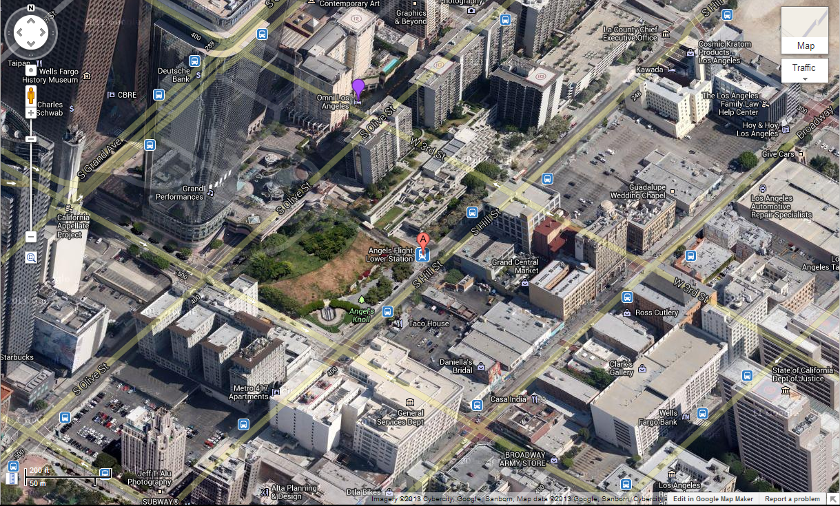

# Handout - Greater Downtown (60 minute round trip)

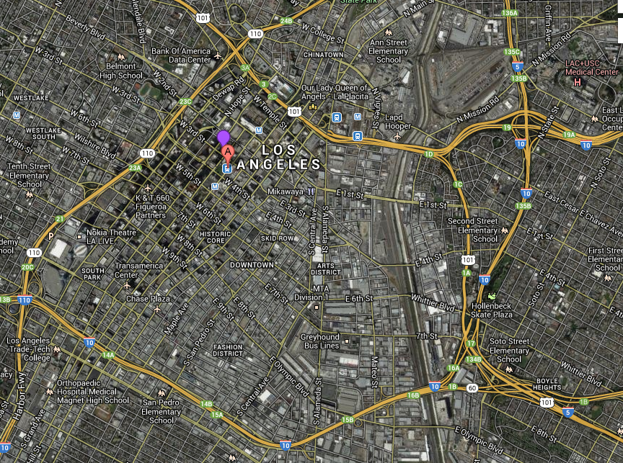

# Handout – Greater Los Angeles (90 minute round trip)

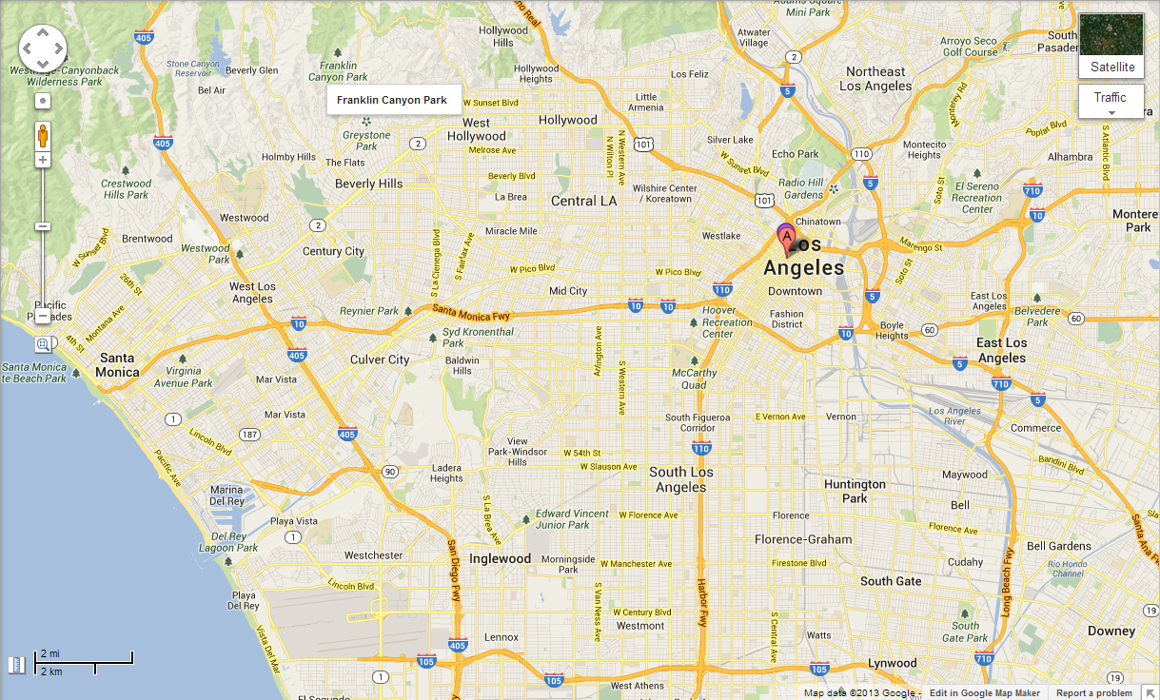

# Handout – Victim’s Tattoo (the Asylum symbol)



# Handout: Approaching the Crime Scene

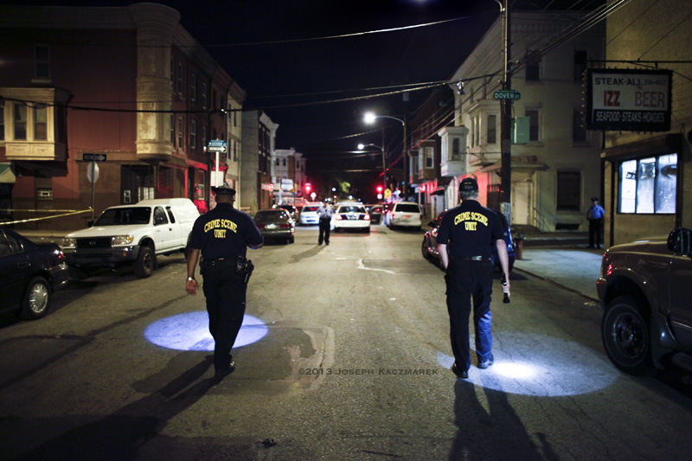

# Handout – Maia’s Laptop Bag and Phone

## Laptop Bag

Contains a billfold with $726 cash, keys to a motorcycle, a decent quality fake ID, and her laptop. A character with the Electronics skill can crack into it.

The contents of the laptop are various notes on old investigations (irrelevant to the current story) and a folder labeled “FLETCHER LAPD INVESTIGATION”

The folder has 3 files. One HTML (website), one text, and one WAV audio.

**The HTML file** is a copy of the news story under *“Handout – Archive News Story”*

**The text file** in that folder, timestamped 6/7/13, 7:55AM, has the following brief note:

Was tailing Sherman. Sherman met with IAG Chief Petri on Santa Monica pier in the morning (Santa Monica is outside LAPD jurisdiction). In the AM, most of the pier is closed except for fishermen. Petri confronted Sherman about the gun. Slam dunk!

**The WAV audio file** in that folder, timestamped 6/7/13, 7:39am, has two men talking:

“If the jury learns that the gun disappeared after an arrest you made just 9 months before it was found on Fletcher, it’ll torpedo the our defense, Will.”

“Ian, I don’t know what to say. I never saw the gun before I found it in Fletcher’s bag.”

“Don’t bullshit me Will. I deserve better after all I’ve done for you. We’re on the same team. We both want to get scum like Fletcher off the streets. You did what you had to do. I’m not here to ass fuck you for it. I’m going to bury this. I’m going to sit on this and push for a settlement.”

“Thanks, Ian.”

“Do you know why I’m going to do that?”

“No, but I have a suspicion you’re about to tell me.”

“I want you to take my job when I’m gone. And you can’t do that if you get busted down for planting a gun.”

“When you’re gone?”

“I’m going to be promoted to the Chief of PSB. And I want a loyal IAG captain.” *[Professional Standards Bureau – the job is a stepping stone to Chief of Police]*

“Well, OK. I can assure you that I’m the man for the job.”

“Great. Where can I get more guys like you, Will?” [They laugh, say goodbye, and depart]

## Phone

Maia’s cheap “burner” phone has photos of the two men talking on the pier, as well as the audio file transcribed above. Her phone has calls to “LATIMER” as well as several fast food places. She didn’t have a lot of friends.

The motorcycle keys go to a bike parked near Latimer’s office, which itself has no other clues on it. It’s registered to Maia’s fake ID.

# Handout – Day 1 News Story

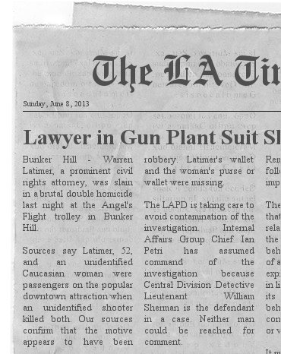

# Handout – Day 3 News Story

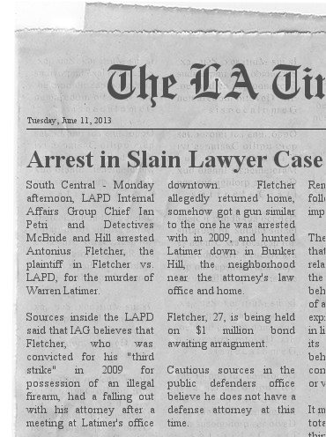

# Handout – Archive News Story

LAPD Under Fire for Illegal Arrest

*LA Times; Friday, May 17, 2013; Los Angeles – Staff Writer*

Antonius Fletcher says when he was pulled over in 2009 in what the Los Angeles Police Department calls a “suspicious behavior stop,” he was sober, employed, and -- most importantly -- unarmed. Fletcher, now 27, had two prior arrests for possession of marijuana with intent do distribute, but he claims he was straight.

Indeed, the arresting officer did not find any drugs in his vehicle, which is where things get complicated. Fletcher's car was searched against his will after a drug sniffing dog indicated the presence of illegal drugs. No drugs were found, but the arresting officer, William Sherman of the LAPD, found an illegal firearm and arrested Fletcher. Worse, as it was his third conviction, the California three-strikes mandate required the judge in his case to sentence him to life in prison.

This case boils with controversy. It touches on the recent revelation of flagrant mis-handling of drug-sniffing dogs, the questionable fairness of the three-strikes law, and accuses a high-ranking LAPD officer, now Lieutenant of the Central Division detective bureau, of planting a gun to get a conviction.

Warren Latimer, lawyer for the plaintiff, has entered a $10 million complaint, and says he will ask the jury in the case to set punitive damages according to how outraged they are at this abuse of police power.

A spokesperson for the LAPD Media Relations bureau pointed out that this is the first they've heard of this complaint, and the LAPD has begun an Internal Affairs group investigation; but warns that while an IAG investigation routinely accompanies any suit of this nature, it is not an indication that the LAPD believes its officer is in the wrong.

# The NPCs

## Victims

Maia, Ex-Asylum Contractor, Private Investigator

Warren Latimer, Famous Lawyer

## Killer

Warren Latimer, Jr., college student, Warren’s son, aka WJ (stats)

## Other Suspects or Witnesses

Dorothy Franks, alimony recipient, cellist, killer’s mother, Warren’s ex-wife (stats)

Harry Liu, Angel’s Flight operator (stats)

Antonius Fletcher, ex-con former pot dealer (stats)

Jennifer Chang, Warren Latimer’s secretary

Jimmy Ross, a lawyer associate of Latimer’s

Gilda Fernandez, Maia’s landlady

## Supernatural Characters

Wick (“short for wicked”), Goblin, gang leader (stats)

Jake J. Jacobson – the PCs’ Asylum handler

Salvador, Host agent (stats)

## LAPD

Cpl. John Parks, LAPD cop (a racist conservative asshole) (stats)

Cpt. Ian Petri, LAPD IAG investigator, crooked cop (stats)

Det. Maurice McBride, LAPD IAG detective 3 (stats)

Det. Sarah Hill, LAPD IAG detective 2 (stats)

Det. Lt. Will Sherman, Central District lieutenant, crooked cop (stats)

PFC. Steve Woiczeski, Cpl. Parks’ partner (a normal guy) (cop-goon stats)

Makayla Johnson, PCs’ LAPD contact, dispatcher

## Goons

Host agent’s goons

Goblin gang banger goons (or, if it comes to it, use these stats for WJ’s roommates)

Low-ranked LAPD beat cop – use for PFC Steve Woiczeski’s stats

# The PCs

Selection of 6 pregens. Generally decent in a fight because they may battle a goblin and his gang or an angel. Otherwise, none of them should be fabulously wealthy, or the mayor or whatnot. Two or (better) three of them should have the divination magic I want to playtest here, so that any 4-man band made out of these characters will have at least one character capable of using magic to locate the murdered contractor’s apartment (where she keeps her paper contract).

* Former detective with friends in the force
  + 50% investigation, 40% combat, 10% contacts and resources
  + investigation, interview, punchy and shooty skills
* Thug type character, like a troll
  + 25% investigation (perception, intimidate, streetwise), 75% combat
  + intimidate skill and very good melee combat
* Shadowy faerie type
  + 60% spying and skulking, 40% combat magic (attack, debuff, buff)
  + good at spying and skulking, maybe has some combat magic
* Ephemera, some sort of shadowy ghost or something
  + 70% magic divided between sneaking and divining,
  + it’s fun to have someone who can go without a body for a while; maybe test out some of your divination magic that would ENHANCE the plot – not instantly solve it.
* Honorable sort, like a knight hospitalier
  + Good mix: 30% combat, 35% magic (heal/buff), 35% streetwise and nice guy social skills
  + good with Relate type skills, melee combat, and streetwise and healing magic
* Reporter type
  + 50% investigation, 20% stealth, 30% contacts and resources
  + stealth, bluff, investigation and interview skills

Skills…

* Academics Reporter
* Athletics Thug, Faerie
* Close Combat **Thug**, Knight, Detective
* Command Detective, Thug, Faerie
* Empathy Detective, Reporter, Knight
* Electronics Reporter
* Mechanics Faerie
* Medicine Detective
* Nature Ephermera
* Occult **Ephemera**, Faerie
* Ranged Combat **Detective**, Faerie
* Relate Detective, **Knight**, Reporter
* Stealth **Faerie**, Ephemera, Reporter
* Streetwise Detective, Knight, **Reporter**